# Derivation of Coefficients in 3x3 kernel

## Coefficients:

Based on Figure 1, given a pixel (in red) and there are 8 pixels surrounding the pixel (central pixel),

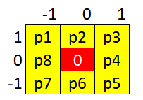

Figure 1. Central pixel with 8 surrounding pixels

$dy$ is the rate of change of image in $y$ direction, while $dx$ is the rate of change of image in $x$ direction. Assume this is in cartesian coordinate system and central pixel (red pixel) is the origin, the coefficients for each pixel within the kernel could be summarized in Equation 1 and Equation 2.

|  |  |
| --- | --- |
| $${coeff}_{{dx}_{i}}=\frac{1}{{dx}_{i}}$$ | (1) |
| $${coeff}_{{dy}_{i}}=\frac{1}{{dy}_{i}}$$ | (2) |
|  |  |

Where $i$ is the pixel index, $coeff$ is the coefficients of kernel, $dx$ is the rate of change of image in $x$ direction, $dy$ is the rate of change of image in $y$ direction.

For $dx$ and $dy$, it could be computed with the Equation 3 and Equation 4.

|  |  |
| --- | --- |
| $$dx=p\left(x_{m}\right)-p(x_{n})$$ | (3) |
|  |  |
| $$dy=p\left(y_{m}\right)-p(y_{n})$$ | (4) |
|  |  |

Where $m$ and $n$ are the opposing index of pixels.

Based on Figure 1:

m = p1, n =p5

m = p2, n =p6

m = p3, n =p7

m = p4, n =p8

m = p5, n =p1

m = p6, n =p2

m = p7, n =p3

m = p8, n =p4

For example, if m = p1, n = p5,

$$dy=p\left(y_{5}\right)-p\left(y_{1}\right)= -1-1= -2$$

$$dx=p\left(x_{5}\right)-p\left(x_{1}\right)= 1-(-1)= 2$$

$${coeff}_{yp1}=\frac{1}{dy}= \frac{1}{-2}=-0.5$$

$${coeff}_{xp1}=\frac{1}{dx}= \frac{1}{2}=0.5$$

By applying similar equations from p2 to p8, the coefficients for $dy$ and $dx$ are shown in Figure 2.

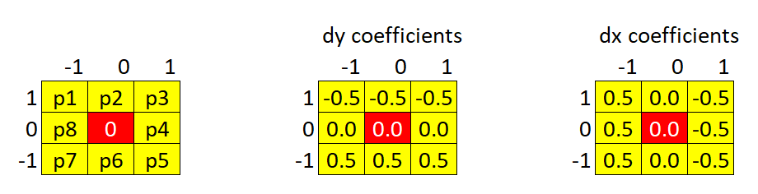

Figure 2. Coefficients for $dy$ and $dx$

The resulting coefficients of kernel are very similar with Prewitt operator, but with weaker power and different direction.

Further information of Prewitt operator:

<https://en.wikipedia.org/wiki/Prewitt_operator>